**Manual for Operating Highcharts Software**

In order to be able to modify charts using XML files, the XML file used must be named ChartXML. There are several options for modifying the chart to be created. All of these options fall into the “chart” section of the XML file. Here is an example of a working “chart” section along with explanations of each of the options:

* Here is an example of a working group of options:

<chart>

<chTitle>SAIR Highcharts</chTitle>

<chSubtitle>2015</chSubtitle>

<yAxisTitle>Stats</yAxisTitle>

<xAxisCategory>Races</xAxisCategory>

<legendAlign>right</legendAlign>

<legendLayout>vertical</legendLayout>

<vertAlign>middle</vertAlign>

<csv>Highcharts test data.csv</csv>

</chart>

* **chTitle**: The name to be displayed above the chart
* **chSubtitle**: The subtitle to be displayed under the main title of the chart
* **yAxisTitle**: The title to be displayed with the y-axis
* **xAxisCategory**: A descriptive title that covers all of the categories displayed in the chart; displayed with the x-axis
* **legendAlign**: Three choices to fill in for this option: ***left, center,*** or ***right***; these choices determine the horizontal placement of the legend in relation to the chart
* **legendLayout**: Two choices to fill in for this option: ***vertical*** or ***horizontal***; these choices determine how the legend is setup; ***vertical***: list-like layout, ***horizontal***: one after another in a line
* **vertAlign**: Three choices to fill in for this option: ***top***, ***middle***, or ***bottom***; these choices determine the vertical placement of the legend in relation to the chart
* **csv**: The name of the CSV file to pull data from; .csv and any spaces in the name must be included; when using a percent sign (%) in the CSV file name make sure to use “%25” instead of just the percent sign

Once the above desired options are filled, a separate “columns” section can be created to choose the column and the data from that column to be displayed in the chart. Here is an example of a working “columns” section:

* <columns>

<vName>Traditional</vName>

<uCName>Prog</uCName>

<value>TRAD</value>

</columns>

* **vNam**e: This is the name to displayed in the legend and with the appropriate data found within the chart
* **uCName**: This is the name of the desired column in the CSV file in which the desired data is found
* **value**: This is the value in the column provided by the name in “uCName” that is wanted to be counted and displayed in the chart

Multiple “columns” sections can be created within the same XML file in order to pull other data from the same CSV file. The only interaction necessary by those using the software is with the XML files. Here is a full, working XML file along with a chart it helped generate:

<?xml version="1.0" encoding="UTF-8"?>

<ChartXML>

<chart>

<chTitle>SAIR Highcharts</chTitle>

<chSubtitle>2015</chSubtitle>

<yAxisTitle>Stats</yAxisTitle>

<xAxisCategory>Races</xAxisCategory>

<legendAlign>right</legendAlign>

<legendLayout>vertical</legendLayout>

<vertAlign>middle</vertAlign>

<csv>Highcharts test data.csv</csv>

</chart>

<columns>

<vName>Black</vName>

<uCName>Rac</uCName>

<value>B</value>

</columns>

<columns>

<vName>White</vName>

<uCName>Rac</uCName>

<value>W</value>

</columns>

<columns>

<vName>Hispanic</vName>

<uCName>Rac</uCName>

<value>H</value>

</columns>

<columns>

<vName>Traditional</vName>

<uCName>Prog</uCName>

<value>TRAD</value>

</columns>

<columns>

<vName>Male</vName>

<uCName>Sx</uCName>

<value>M</value>

</columns>

<columns>

<vName>Female</vName>

<uCName>Sx</uCName>

<value>W</value>

</columns>

</ChartXML>

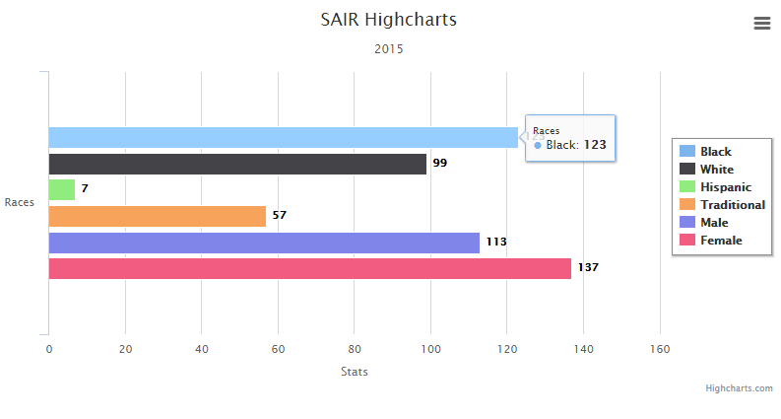

The above chart is a bar chart. There is a separate set of code for creating a column chart. The same XML file can be used for both sets of code. The code for a bar chart is called “Bar Chart.html”, and the code for a column chart is called “Column Chart.html.”

If there is any problem or desired addition to the software, please contact the current overseer of the code.